* Linear Layout can be horizontal or vertical.
* **Android: orientation+ = “horizontal”.** For example ->

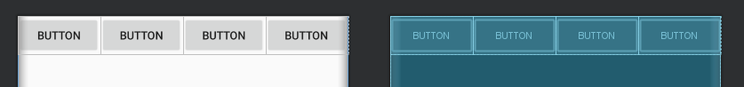

* **Android: orientation =” vertical”** for example ->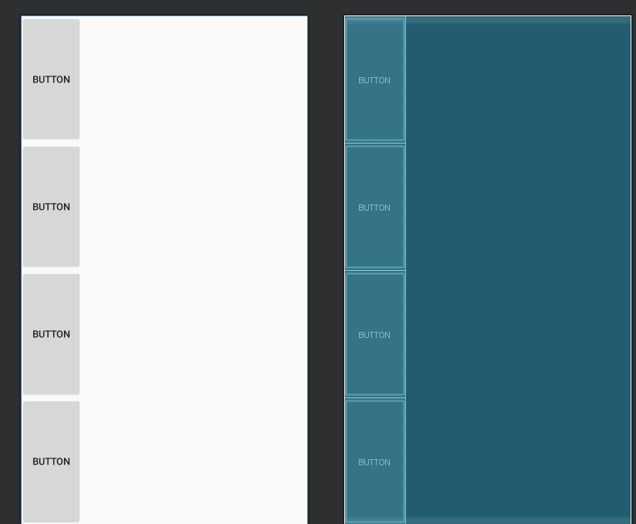
* **Background** is the property that sets the background.
* **Orientation** is the property that sets the orientation to horizontal or vertical
* **Layout_height and Width** is two important properties. If we set value to **match parent**, it will take all the space as parent takes. If we set the value to **wrap_content**, it will take only as much space as the content takes.
* **Weight** is important property. It tells how much portion of the layout the widget will take. For example, if we have a Linear layout with 2 buttons, and we set weight to 1 for each button, both will take half of the available space.
* **Gravity** is another property which tells us how the position of the child element inside the layout is defined.
* **CenterinParent** is something we can use for Relative Layout. Each layout has its own properties and some are different.
* **Important ->**

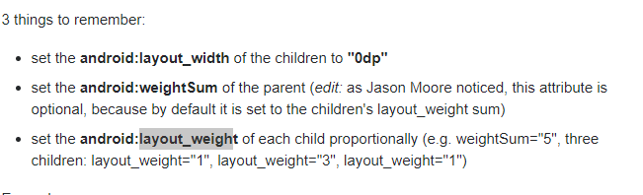

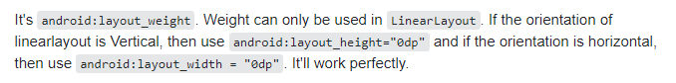

* **Gravity vs layout_gravity ->**

